**Datos Utilizados para la generación del DataSet:**

Altura, Periodo y dirección de la ola registrado por la boya 106.

Altura, Periodo y dirección de la ola registrado por el modelo WW3 .

Observacion Visual de la altura de la ola desde la playa Sunset, ubicada en la costa norte de Oahu, Hawaii.

Los datos utilizados corresponden al año 2002.

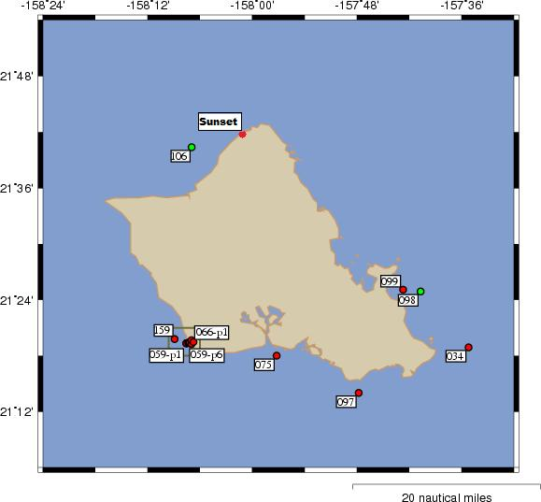

**Preprocesamiento y armado de las instancias:**

Las observaciones visuales carecen de información acerca del momento del dia en que fueron hechas, pero si se sabe que las mismas representan la altura máxima registrada durante el dia.

Para acoplar las lecturas de las boyas a las observaciones visuales se removieron todas las lecturas de boyas que corresponden al periodo nocturno dejando solo las lecturas comprendías entre las 7 AM y 8 PM, luego se eligio, para cada dia, la lectura de boya que correspondía a la altura maxima.

Una vez acoplados los datos de las boyas con las observaciones visuales, se añadieron los datos correspondientes al modelo WW3. A cada lectura de boya/observación visual se le asociaron los datos del modelo WW3 más recientes a la hora de la lectura de la boya.

**Instancia resultante:**

B.WH||B.WPB|| B.WD|| WW3.WH||WW3.WP||WW3.WD||VO.WH

B: buoy; WW3: wave watch 3 model: VO: Visual observation.

WH: Wave Height (meters); WP: Wave Period (seconds); WD: Wave Direction (degrees).

**Pruebas y resultados:**

Se probaron los algoritmos de aprendizaje de maquina: Perceptron Multi Capa, Regresión Lineal y maquinas de soporte vectorial. Para la prueba de los mismo se utilzo el mismo dataset y se utilizo 10 fold cross-validation.

**Percpetron multi capaz:**

=== Run information ===

Scheme: weka.classifiers.functions.MultilayerPerceptron -L 0.3 -M 0.2 -N 500 -V 0 -S 0 -E 20 -H a

Relation: NoDirectionStrategy

Instances: 360

Attributes: 7

buoyHeight

buoyPeriod

buoyDirection

ww3Height

ww3Period

ww3Direction

visualObservation

Test mode: 10-fold cross-validation

=== Classifier model (full training set) ===

Linear Node 0

Inputs Weights

Threshold 0.14355623624420924

Node 1 2.1669537409984185

Node 2 -0.4037107728579187

Node 3 -0.8112455015600912

Sigmoid Node 1

Inputs Weights

Threshold -5.953479000518505

Attrib buoyHeight 2.34595246478119

Attrib buoyPeriod -1.8412028090742831

Attrib buoyDirection 1.0986097685642542

Attrib ww3Height 0.7123746860790937

Attrib ww3Period 4.327296961594959

Attrib ww3Direction -0.5424016005755499

Sigmoid Node 2

Inputs Weights

Threshold -2.7815620887265973

Attrib buoyHeight -2.734069290330381

Attrib buoyPeriod -1.4241122548520821

Attrib buoyDirection -0.07012043951261168

Attrib ww3Height -0.9128367448682483

Attrib ww3Period 0.16597296322148974

Attrib ww3Direction -0.724303225347969

Sigmoid Node 3

Inputs Weights

Threshold 3.7385769001308815

Attrib buoyHeight -4.076653195075439

Attrib buoyPeriod -5.29275098199757

Attrib buoyDirection -1.0510500666122002

Attrib ww3Height 0.15470319206645228

Attrib ww3Period 1.0779025179306243

Attrib ww3Direction -1.402262092992803

Class

Input

Node 0

Time taken to build model: 0.99 seconds

=== Cross-validation ===

== Summary ===

Correlation coefficient 0.8724

Mean absolute error 1.0406

Root mean squared error 1.4549

Relative absolute error 51.8027 %

Root relative squared error 52.004 %

Total Number of Instances 360

**Regresion Lineal:**

=== Run information ===

Scheme: weka.classifiers.functions.LinearRegression -S 2 -D -R 1.0E-8

Relation: NoDirectionStrategy

Instances: 360

Attributes: 7

buoyHeight

buoyPeriod

buoyDirection

ww3Height

ww3Period

ww3Direction

visualObservation

Test mode: 10-fold cross-validation

=== Classifier model (full training set) ===

Linear Regression Model

visualObservation =

1.7331 * buoyHeight +

0.2758 * buoyPeriod +

0.0032 * ww3Direction +

-4.1394

Time taken to build model: 0.04 seconds

=== Cross-validation ===

=== Summary ===

Correlation coefficient 0.8848

Mean absolute error 0.9174

Root mean squared error 1.3007

Relative absolute error 45.6733 %

Root relative squared error 46.4924 %

Total Number of Instances 360

**Maquinas de soporte vectorial:**

=== Run information ===

Scheme: weka.classifiers.functions.SMOreg -S 0.0010 -C 1.0 -E 1.0 -G 0.01 -A 250007 -T 0.0010 -P 1.0E-12 -N 0

Relation: NoDirectionStrategy

Instances: 360

Attributes: 7

buoyHeight

buoyPeriod

buoyDirection

ww3Height

ww3Period

ww3Direction

visualObservation

Test mode: 10-fold cross-validation

=== Classifier model (full training set) ===

SMOreg

Kernel used :

Linear Kernel : K(x,y) = <x,y>

Machine Linear: showing attribute weights, not support vectors.

(normalized) visualObservation =

0.4331 * (normalized) buoyHeight

+ 0.222 * (normalized) buoyPeriod

+ 0.0023 * (normalized) buoyDirection

+ -0.0119 * (normalized) ww3Height

+ -0.0039 * (normalized) ww3Period

+ 0.0859 * (normalized) ww3Direction

- 0.1237

Number of kernel evaluations: 64980 (100 % cached)

Time taken to build model: 1.06 seconds

=== Cross-validation ===

=== Summary ===

Correlation coefficient 0.8821

Mean absolute error 0.8934

Root mean squared error 1.3677

Relative absolute error 44.4791 %

Root relative squared error 48.8841 %

Total Number of Instances 360